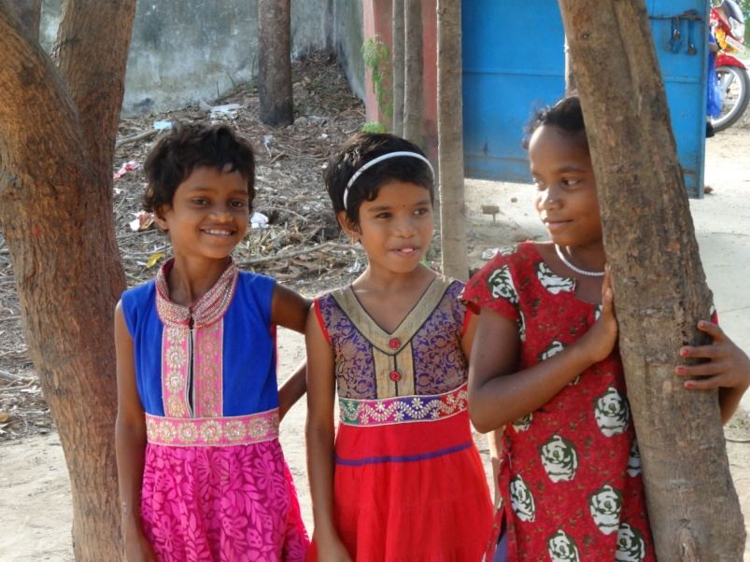

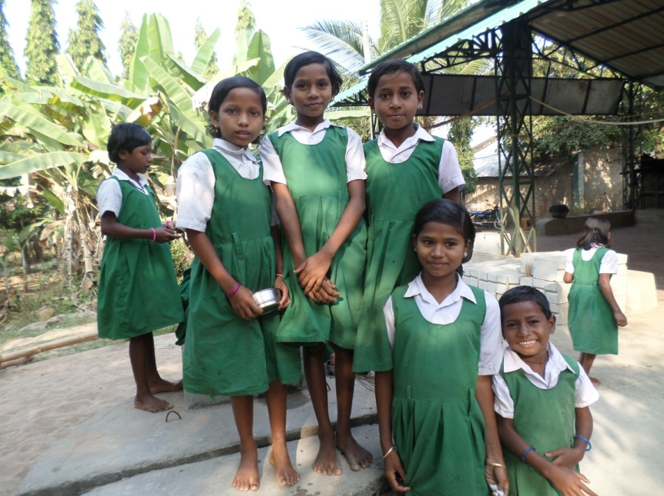

**Who are we?**

Social Education for Environment and Development (SEED) is a voluntary organization created in 1991 by a group of committed social workers. Since inception, it has been working for socio-economic and cultural development of the aboriginal tribes in Malkanagiri District of Orissa. SEED has direct involvement with 50,000 persons in Malkangiri district and it has impacted the lives of nearly 100,000 people in total since its inception.

**Where do we act?**

Malkanagiri is located 750km away from Bhubaneswar, the State capital of Odisha. India, SEED works to improve the lives of scheduled tribe and scheduled caste communities, which represents more than 90% of the organization’s beneficiaries. Distressed women, children, laborers, and landless persons are always prioritized in SEED’s interventions.

**What is the situation in Malkanagiri?**

* **Inadequate availability of facilities and quality of education** that has a strong bearing on the efficiency of the education system. The tribe Koya community is living in the forest density and hilly area where there is no schooling facility in the vicinity: the schools are within 5 to 15 km distance from the villages.
* **Rampant poverty** retards the children from regular school attending and led to child labor. Young girls are engaged in collection of forest products, rearing of cows, goats’ piggeries and carrying of babies in their home.
* **Non-consciousness girl’s education** in this area.
* **Political instability:** The area is seriously affected and acquired by anti-social Nexle groups which break ongoing development in the area.

|  |  |
| --- | --- |
| Malkanagiri Female literacy rate in 2011 | 38.95% |
| Odisha female literacy rate in 2011 | 64.36% |

*There is a* ***vicious circle of poverty*** *and illiteracy where families need their children to work and are not aware about the importance of education.*

**What do we do?**

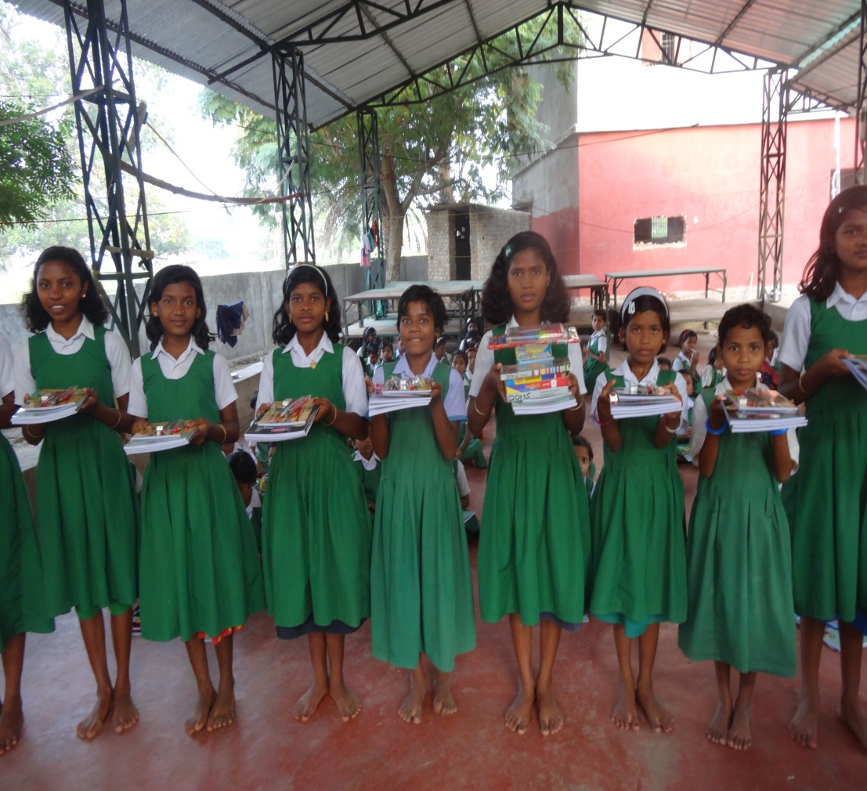SEED initiated an educational complex for tribal girls at S. Tandapalli village of Korkunda Block in Malakanagiri. Then, after several meetings with the village community, the local girls were enrolled in the residence school for primary education (class 1 to class V). The school was started in the year 1998 and can count tribal girls aged 6-14years. The sole Mission of the ECTG (Educational Complex for Tribal Girls) is to increase women literacy in Malkangiri district. Teachers use different innovative methods to enhance the mental ability of the children and create enthusiasm among children to learn. The children are imparted residential facilities with food, teaching learning materials, and sundry items, health check up, entertainment facilities, games, and joyful education etc to the school children on a regular basis.

**Why do we need you?**

Our problem today is that there is not any regular source of income to maintain the school. Then, we are facing financial difficulties. Many girls have dropout of the school because their family don’t send them anymore. It is either because the school is too far, either because of teaching problems (Tribal language) or their parents engaged them in different household activities. Due to our financial problems (we never know if the government is going to help us or not and we didn’t receive money the past two years) we were not able to appoint enough teachers and their salary was not efficient to keep them long enough. We recently found a new Headmaster and we now miss only two teacher. At that time, we need help to continue paying them and the other fees for the girls who includes their accommodation, health care, uniform dress, Vocational equipments and materials for training ( tailoring machine, computer) and school material. Those girls really have a great potential and it would be a shame that no one can help them. We ask today some help for 142 students for about 1000Rs per month per students. This is a global budget; you are free to give the amount that is the most convenient for you it may be partial or full amount does not matter but your support is highly essential at this moment. .

**How to help?**

There are different possibilities to help us. You can choose to give to the all school the amount you choose per month, either you can choose to completely follow one particular girl from the grade you want and we will send you particular information about her, pictures and more details. Also supporting one part of our program is possible if it is more convenient for you and you can for example provide all the uniforms for a year or the health care facilities. We will share the evolutions with you every six months with details of how the money was spent and how the living and teaching conditions are increased. You can send the money directly to the bank account of the school.

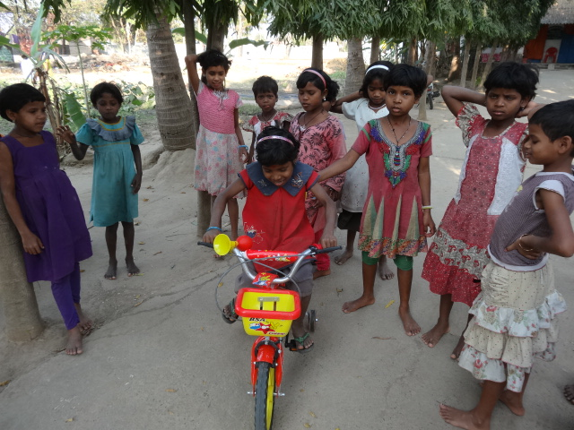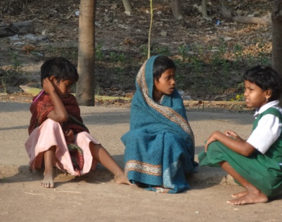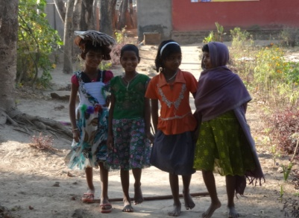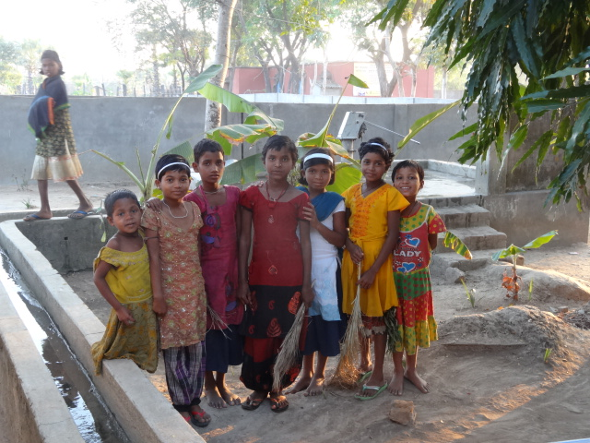

**Our request for sponsorship**

|  |  |  |
| --- | --- | --- |
| Sl. No | Particulars | Amount in INR |
|  | Students |  |
| 1. | Food stuff for per students per month for 10 month | 7500 |
| 2 | Uniform dress /shoes 2 pairs per Annum | 1000 |
| 3 | Books and teaching learning materials 1000 per annum | 1000 |
| 4 | Health care for 10 month | 500 |
| 5 | Co curricular activities for 10 month | 1000 |
|  | Per students for academic year | 11000 |
|  | Campus |  |
| 7 | Computer 1, x INR 50,00 | 50000 |
| 8 | Tailoring machine 05 no x INR 10000 | 50000 |
| 9 | Sleeping beds 50 no x INR 5000 | 25000 |
| 10 | Playing materials and equipments | 100000 |
| 11 | Construction Kitchen | 180000 |
|  | Staff |  |
| 11 | One head master INR 7000 Per month x 12 month | 84000 |
| 12 | Three teacher INR 5000 Per month x 12 month | 180000 |
| 13 | One language teacher INR 5000 Per month x 12 month | 60000 |
| 14 | Two cook, one peon, one night watcher =4staff INR 4000 per month x 12 month | 192000 |